**Project report**



**CRICKET GAME**

**TEAM MEMBERS: SUBMITTED TO:  
ZAID BIN TARIQ 24K-0789 MS. KHADIJA TUL QUBRA  
SUBHAN RAZZAQ 24K-0784  
ASAD ULLAH BIN TUFAIL 24K-0801  
(BCS – 1E)**

Introduction:

What is the Project?

Our project is a turn based, 2 players, cricket game simulation made using C programming language.

What does it do?

The program takes the input from both the players but keeps the input hidden from each other. If both inputs are same, a wicket is counted. If the inputs are different, the score in added in batsman tally.

Why did we choose it?

Reason for choosing this project was: It is interactive, and we also have real life experience of playing this game. Another reason was that the program also uses many programming concepts that we have learnt in our classes.

Design & Implementation:

**PSEUDOCODE and ALGORITHM:**

MAIN COMPONENTS:

1- Menu  
2- Toss  
3- Setting Target  
4– Chasing Target  
5– Super Over  
6– Exit

* Program uses switch statement in Menu() function to decide which option has been selected.
* If a classic game is selected, then the Toss() function is called, the Toss() function decides between Heads and Tails using rand() built-in function and one of the player is given option to selected between bat or ball.
* Then the Target() function is called. Both users enter an input which is kept hidden using getch() built-in function. If both inputs are different and within acceptable ranges, this score is added in score1 using switch function.
* If both inputs are same, then it is counted as a wicket and Chase() function id called. This function works on the same principles. After every ball score2 is compared with score1.
* If score2 exceeds score1, then Player 1 wins else Player 2 wins. If both score1 and score 2 are equal, then SuperOver() is called,
* SuperOver() then calls Target(6) again to decide the winner but only limited number of balls are played (i.e. 6).

**Flowcharts:**  
  
  
**MENU:**

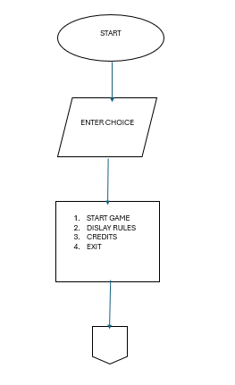

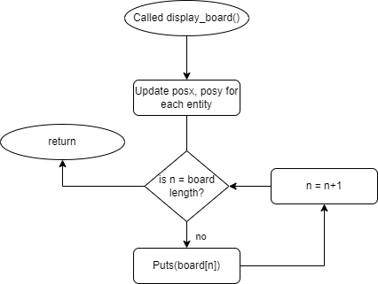   
**SET TARGET:**

**CHASING TARGET:**

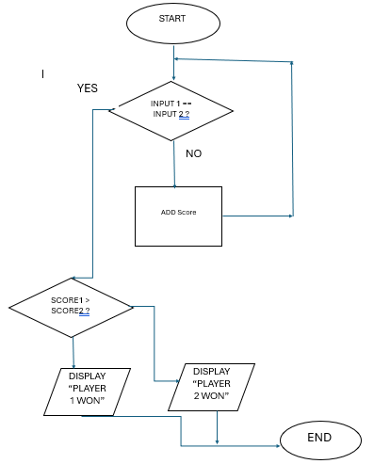

Results:

**MENU**

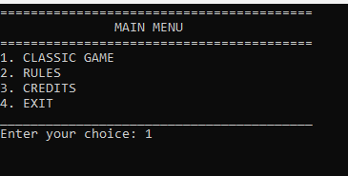

**TOSS**

**SETTNG TARGET**

**CHASING TARGET**

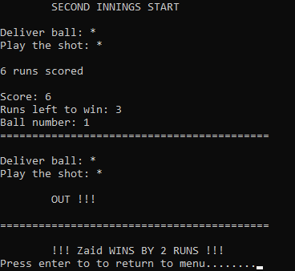

References:

1. <https://youtu.be/4E59FvBzoZY?si=QdMO16_amMcknS4m>
2. https://youtu.be/mBT79DS8fl4?si=KJzisfOW8g_YmV73